*Highway Racers*

By *Core5*

**Overview/Theme** **2**

Idea Summary 2

Goal 2

Why It Will Succeed 2

**Mock Ups** **3**

**References** **3**

**Art Style** **3**

**Look & Feel / Camera** **4**

**Mechanic** **4**

Controls 4

Core Loop (Feel Free to Replace Diagram Below) 5

**Progression** **5**

# Overview/Theme

## Idea Summary

“Highway Racers” will be a 3d bike mobile game, having a bike as a protagonist that will face different obstacles on the way. The user would be able to move the bike by tilting the phone. The only way for the game to end will be the bike hitting an obstacle three times because it's going to be an endless game. One hit with an obstacle will only damage the player/bike. We will keep different pickable power ups on the road for the user, such as speed increases, temporary invulnerability, and bike repairs.

It will be an easy to play yet difficult to master game. The user will be given an easily understandable aim and simple gaming controls.

## Goal

The ultimate aim of the player is to enjoy the bike ride while dodging traffic and obstacles along the way. Moreover, the goal of the player is to collect as many coins/score as possible and use those coins to unlock premium assets in the garage. This also increases the motivation of the player to keep playing the game and unlock new bikes and game modes/stages.

Also, the aesthetics of the game will make it more appealing, fun, and entertaining for the users.

# Mockups

Use mockups that you have made, stock images, game screenshots or doodles to showcase how the game works. The quality / accuracy of the image doesn’t matter, it can be a badly drawn doodle but should explain the core game.

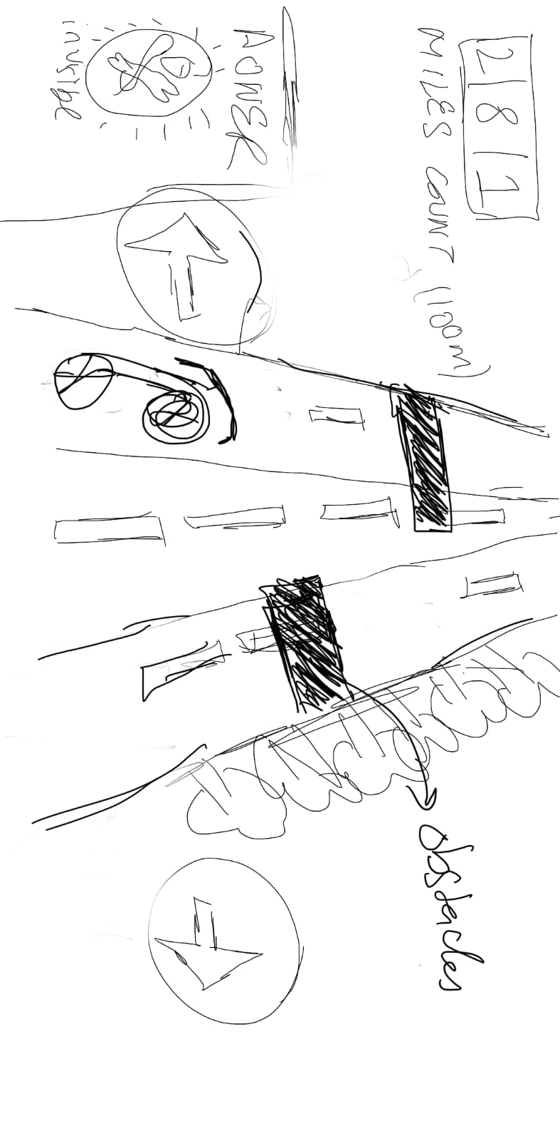

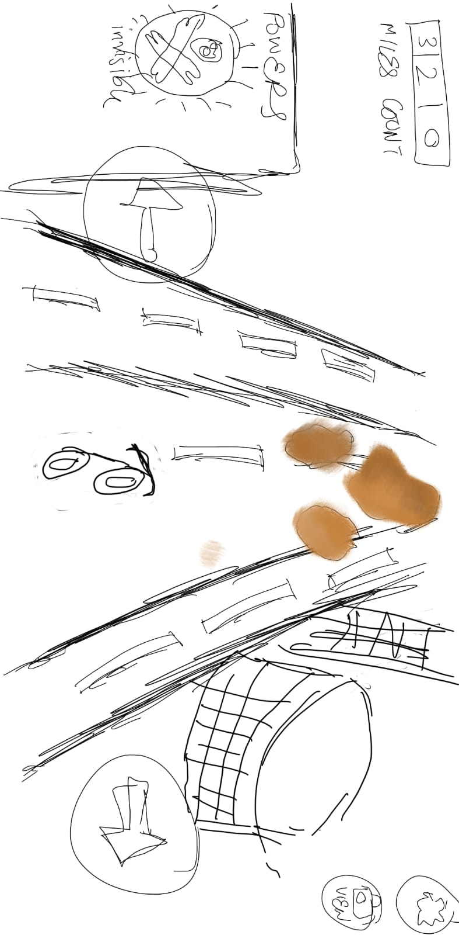

# References

The following game closely resembles the game that we want to develop. We will be using power-ups and health system in the game so the player will have more than one chance before the game ends. Also, we will be designing more unique obstacles, and smooth turns on the roads (to make the game more engaging) as the difficulty level increases.

<https://play.google.com/store/apps/details?id=com.batteryacid.highwayrider&hl=en_US&gl=US\>

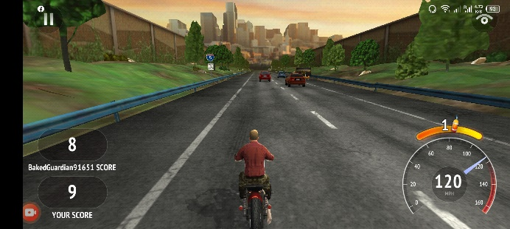 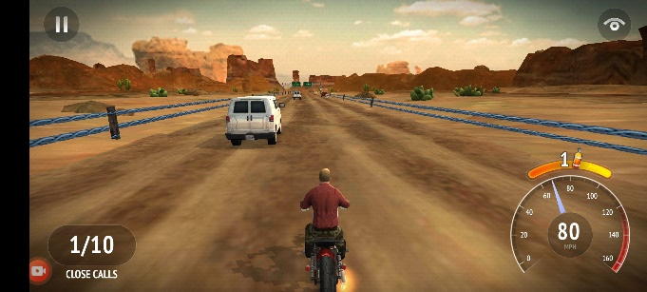

 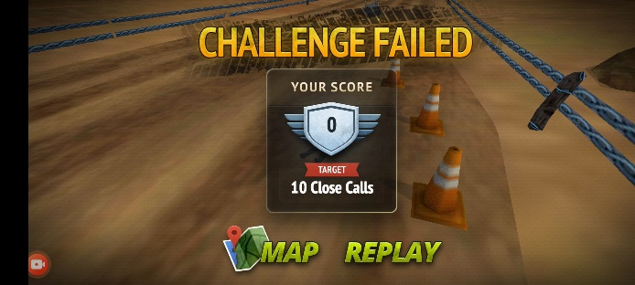

# Art Style (check any number of boxes that apply)

* 2D
* 3D
* Pixel
* Cartoon
* Cell Art
* Low Poly
* High Poly
* Photo Realism
* Stylized Realism
* Isometric
* Other

## Sample images or references

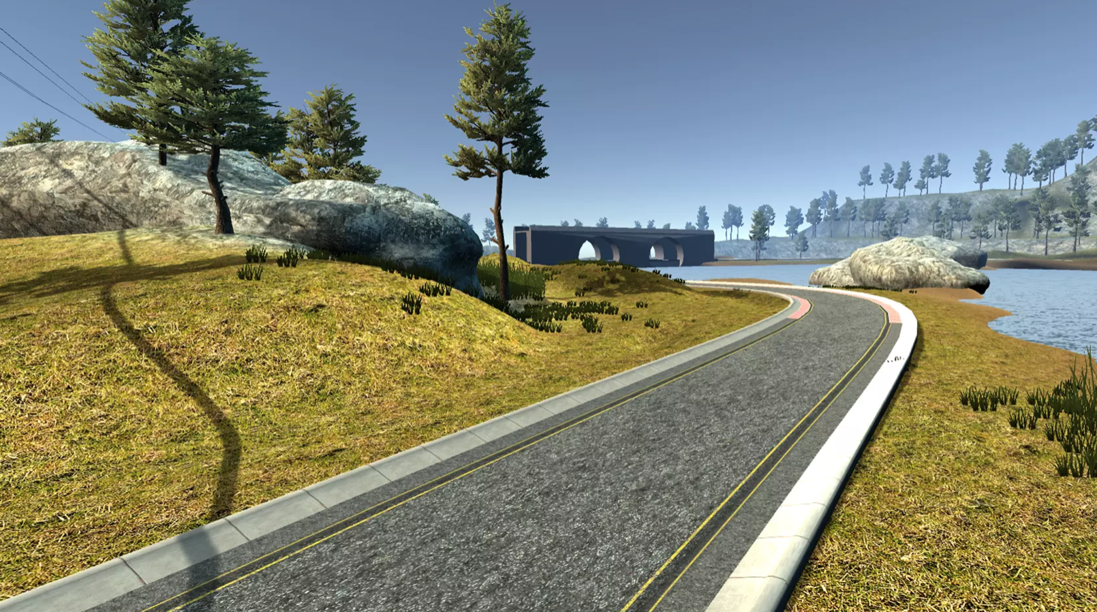 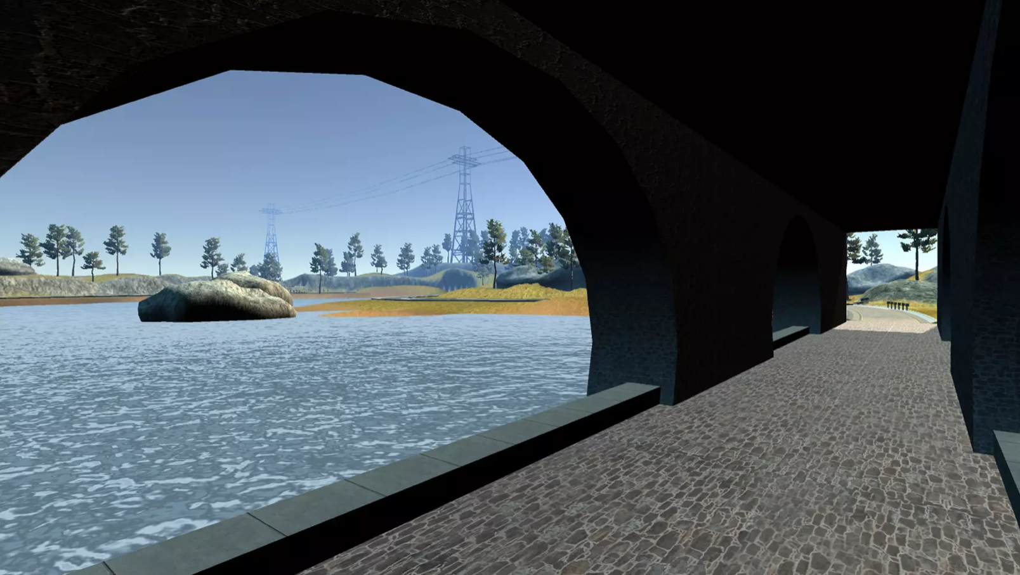

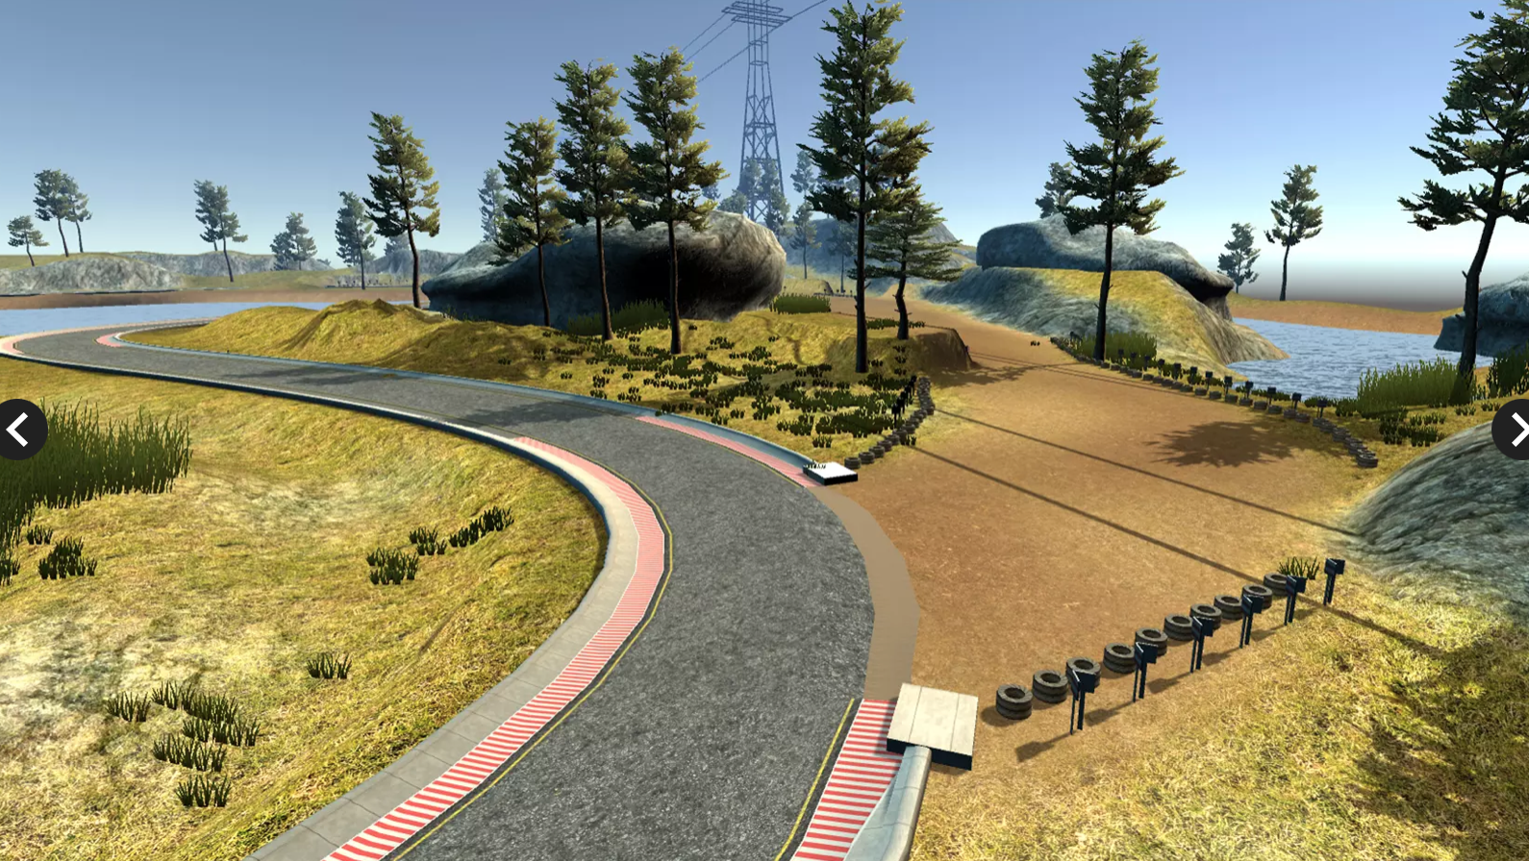 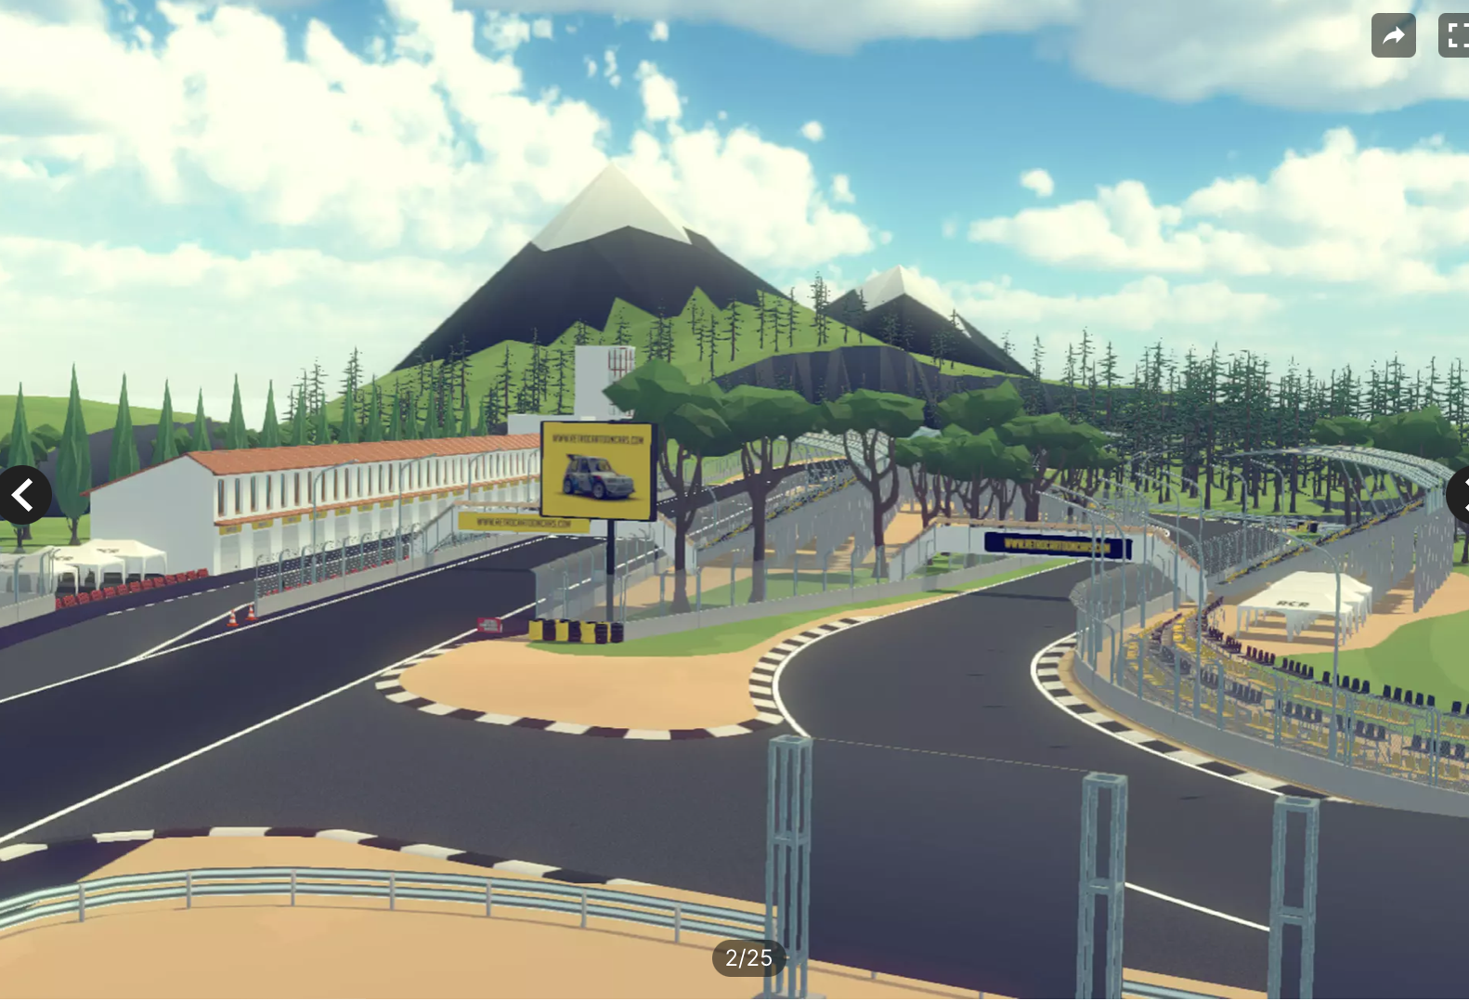

# Look & Feel / Camera

* First Person
* Third Person
* Over The Shoulder
* Top Down
* Face On
* Other

The camera will be above and behind the player’s bike, looking downwards at the bike with a slightly acute angle. The player will be able to see their entire bike, the road ahead, and some part of the road behind their bike as well.

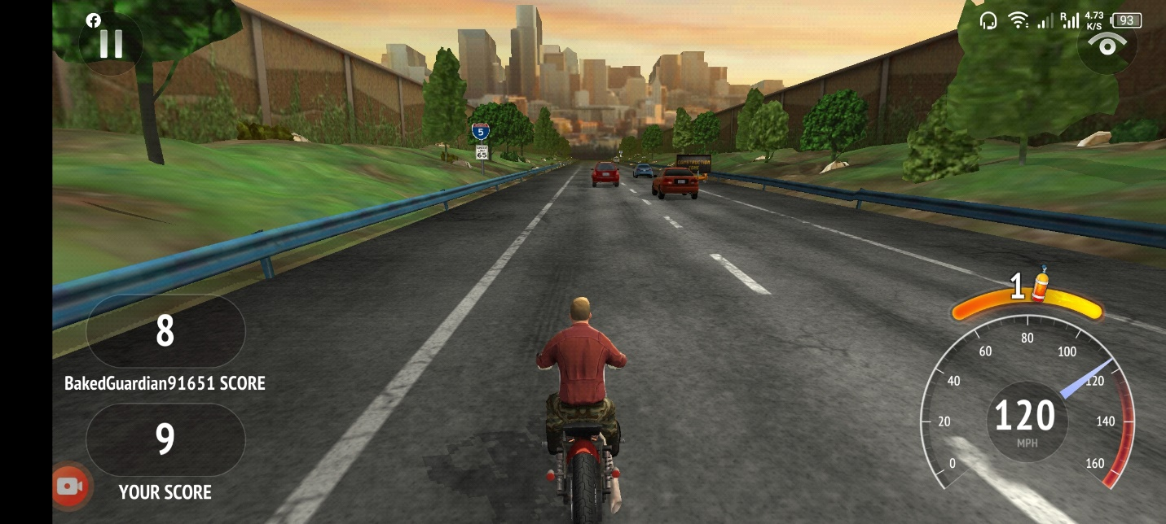

# Mechanic

## Controls

* Portrait
* Landscape
* Single Touch
* Joystick
* Tap
* Slide
* Swipe
* Hold
* Release
* Drag
* Other
* For Each Checked Item, please provide an explanation

**Landscape:**

The game screen will be laid out in landscape view, to cover the width of the road better.

**Tap:**

The player will be able to tap the view button to change the camera view, pause button to pause the game, and display the game menu, etc.

**Other:**

The player will tilt the phone sideways to steer the bike right or left.

## Core Loop (Feel Free to Replace the Diagram Below)

Player taps to starts the game.

Player maneuvers bike to avoid obstacles and uses powerups.

Player eventually collides with an obstacle.

On 3 hits, player’s bike is totaled and the game ends.

# 

# Progression

* Level Based
* Score Based
* Upgrade Based
* Star Based
* % Complete Based
* Engagement Based
* Content Based
* Other
* Briefly describe how the progression in the game works.

As the player/bike travels farther, the score keeps increasing with the increase in distance covered, collection of coins on the road, and close calls. Moreover, the number of obstacles appearing also increases with time causing the game to become difficult and challenging for the player.